PHENIKAA UNIVERSITY
SCHOOL OF COMPUTING

SOFTWARE ARCHITECTURE FINAL PROJECT REPORT

BadNet - Badminton Social Network and Pool Betting Platform

Group 5
Dinh Quang Lap - 23010416
Nguyen Hoang Thai Bao - 23010120

Supervisor: Software Architecture Course Instructor
Academic Year: 2025-2026
Submission Date: June 16, 2026

Table of Contents
1. Project Overview
2. Requirements Analysis (SRS)
3. Architecture and System Design (SDD)
4. Implementation and Coding
5. System Testing
6. Deployment and User Guide
7. Conclusions and Future Work
References

List of Figures
Figure 1. BadNet use case diagram
Figure 2. C4 Level 1 - System context
Figure 3. C4 Level 2 - Container diagram
Figure 4. C4 Level 3 - Component diagram
Figure 5. C4 Level 4 - Code diagram
Figure 6. Database entity relationship diagram
Figure 7. Domain class diagram
Figure 8-12. Sequence and activity diagrams
Figure 13-15. System screenshots

Chapter 1: Project Overview

1.1 Problem Statement
BadNet is a web platform for badminton communities where players can post updates, find opponents, join teams, register for tournaments, manage match schedules and participate in virtual pool betting. In many amateur badminton clubs, match discovery, court coordination, team organization and result tracking are still handled through disconnected chat groups or spreadsheets. This makes it hard to verify match results, notify players reliably, and keep a transparent record of betting or virtual-point transactions.
The project addresses this gap by combining a player-facing social network with an operations-focused admin panel. The architecture emphasizes data integrity for betting and wallet transactions, real-time notification awareness, role-based moderation, and a consistent responsive interface for both light and dark mode.

1.2 Project Objectives
ID | Objective | Measurement
OBJ-01 | Provide at least eight player functions: authentication, posts, comments, notifications, challenges, matches, teams, tournaments and betting. | Implemented as Laravel routes and Blade/React views.
OBJ-02 | Provide an admin panel for users, roles, wallet balances, betting markets, tournaments, content moderation and audit logs. | Admin routes protected by auth and admin middleware.
OBJ-03 | Protect betting and wallet integrity using database transactions, row locks and ledger records. | BetService and WalletService use DB::transaction and lockForUpdate.
OBJ-04 | Document architecture with C4, ERD, UML, API design and ADRs. | Included in Chapters 2 and 3.
OBJ-05 | Prepare at least 30 functional test cases mapped to requirements. | Included in Chapter 5.

1.3 Project Scope
In scope: account registration with email verification, password reset, home feed, challenges, matches, teams, tournaments, pool betting, notifications, profile, admin players, admin betting, admin moderation, admin statistics and audit logging. Out of scope: native mobile applications, real payment gateways, official BWF data integration, production-grade anti-fraud machine learning and multi-tenant deployment.

1.4 Technology Stack Overview
Layer | Technology | Purpose
Backend | Laravel 9, PHP 8.1 | MVC routing, controllers, services, validation and Blade rendering.
Frontend | Blade, vanilla CSS, React, Vite | Server-rendered views and interactive player portal widgets.
Database | MySQL | Persistent storage for users, posts, matches, bets, teams, tournaments and ledgers.
Realtime-ready | Laravel events, Echo/Pusher compatible structure | Notification and pool movement events.
Testing | PHPUnit / Laravel test runner | Automated regression checks for key workflows.

Chapter 2: Requirements Analysis (SRS)

2.1 Functional Requirements
ID | Requirement | Priority
FR-01 | Users can register, verify email with a code, login, logout and reset password with a 15-minute token. | High
FR-02 | Users can create, like, comment, delete and view social posts. | High
FR-03 | Users can find opponents, create challenges, accept/reject invitations and create matches. | High
FR-04 | Users can create or join teams and view team members. | High
FR-05 | Team leaders and admins can add or remove team members. | High
FR-06 | Users can create, browse, view and join tournaments. | High
FR-07 | Tournament organizers and admins can add or remove participants. | High
FR-08 | Users can place virtual-point bets on eligible matches. | High
FR-09 | The system locks stakes immediately and records all wallet changes in a ledger. | High
FR-10 | Admins can approve, cancel, update or delete betting odds. | High
FR-11 | Admins can ban, delete, restore users and set roles including admin. | High
FR-12 | Admins can adjust user wallet balances with an audit reason. | High
FR-13 | Users receive categorized notifications with unread, pinned, mark-read and deep-link actions. | Medium
FR-14 | Admin statistics and betting charts display tooltip values on pointer movement. | Medium
FR-15 | The UI supports light and dark modes with shared CSS tokens. | Medium

2.2 Non-Functional Requirements
ID | Quality Attribute Scenario | Response Measure
NFR-01 Availability | When a regular user opens the home feed during normal operation, the system shall render the feed and right panel without requiring admin services. | Page responds within acceptable demo latency on localhost.
NFR-02 Integrity | When two users bet on the same match concurrently, the wallet balance and pool totals shall remain consistent. | Transactions use row locks and no negative balance is allowed.
NFR-03 Security | When an unauthenticated user accesses admin routes, the system redirects or blocks the request. | All admin routes are behind auth and admin middleware.
NFR-04 Usability | When users switch theme, core pages maintain readable contrast. | Light and dark modes use tokenized colors.
NFR-05 Maintainability | When adding a new betting operation, changes are localized to controller/service/model layers. | Business rules are centralized in BetService and WalletService.

2.3 Use Case Diagram and Use Cases
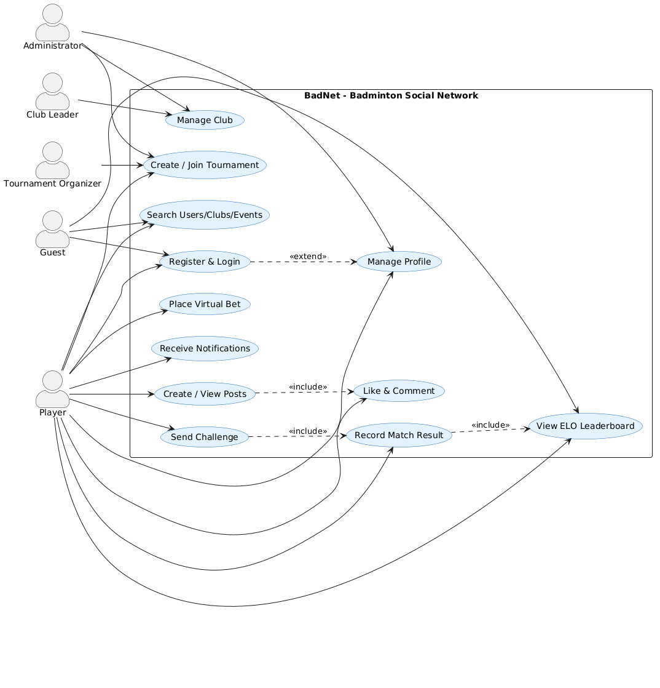
Figure 1. BadNet use case diagram.
Use Case | Actor | Main Flow | Exception
Register and verify email | Guest | Submit registration form, receive verification code, enter code, access dashboard. | Invalid or expired code requires resend.
Create challenge | Player | Choose target player, skill level, type, court/time and send invitation. | Target rejects or match slot becomes unavailable.
Place bet | Player | Open bet slip, choose winner, enter stake, confirm, wallet stake is locked. | Insufficient balance disables confirmation.
Manage betting market | Admin | Review market, update odds, approve, suspend or cancel. | Completed market cannot accept new bets.
Moderate user/content | Admin | Search user/post, ban/delete/restore and record audit entry. | Admin cannot perform unauthorized action without role.

2.4 Architecturally Significant Requirements
ASR | Driver | Architectural Decision
ASR-01 Betting integrity | Wallet and betting operations must not corrupt balances. | Use DB transactions, lockForUpdate, WalletTransaction ledger and idempotent references.
ASR-02 Admin control | Moderation and financial actions require strong authorization. | Use role field, admin middleware, protected admin route group and audit log.
ASR-03 Notification clarity | Users must separate social, match, system and betting notices. | Notification model stores type/category/read/pinned/target_url.
ASR-04 UI consistency | Player and admin surfaces must share visual behavior. | CSS variables and shared fonts: Barlow Condensed, Inter, JetBrains Mono.

Chapter 3: Architecture and System Design (SDD)

3.1 Architectural Style Selection
BadNet uses a layered MVC architecture. Laravel routes dispatch HTTP requests to controllers, controllers validate input and delegate domain logic to services, services coordinate Eloquent models and database transactions, and Blade/React views render the user interface. This style matches the project scale and keeps business rules testable while still allowing fast UI iteration.

3.2 C4 Model
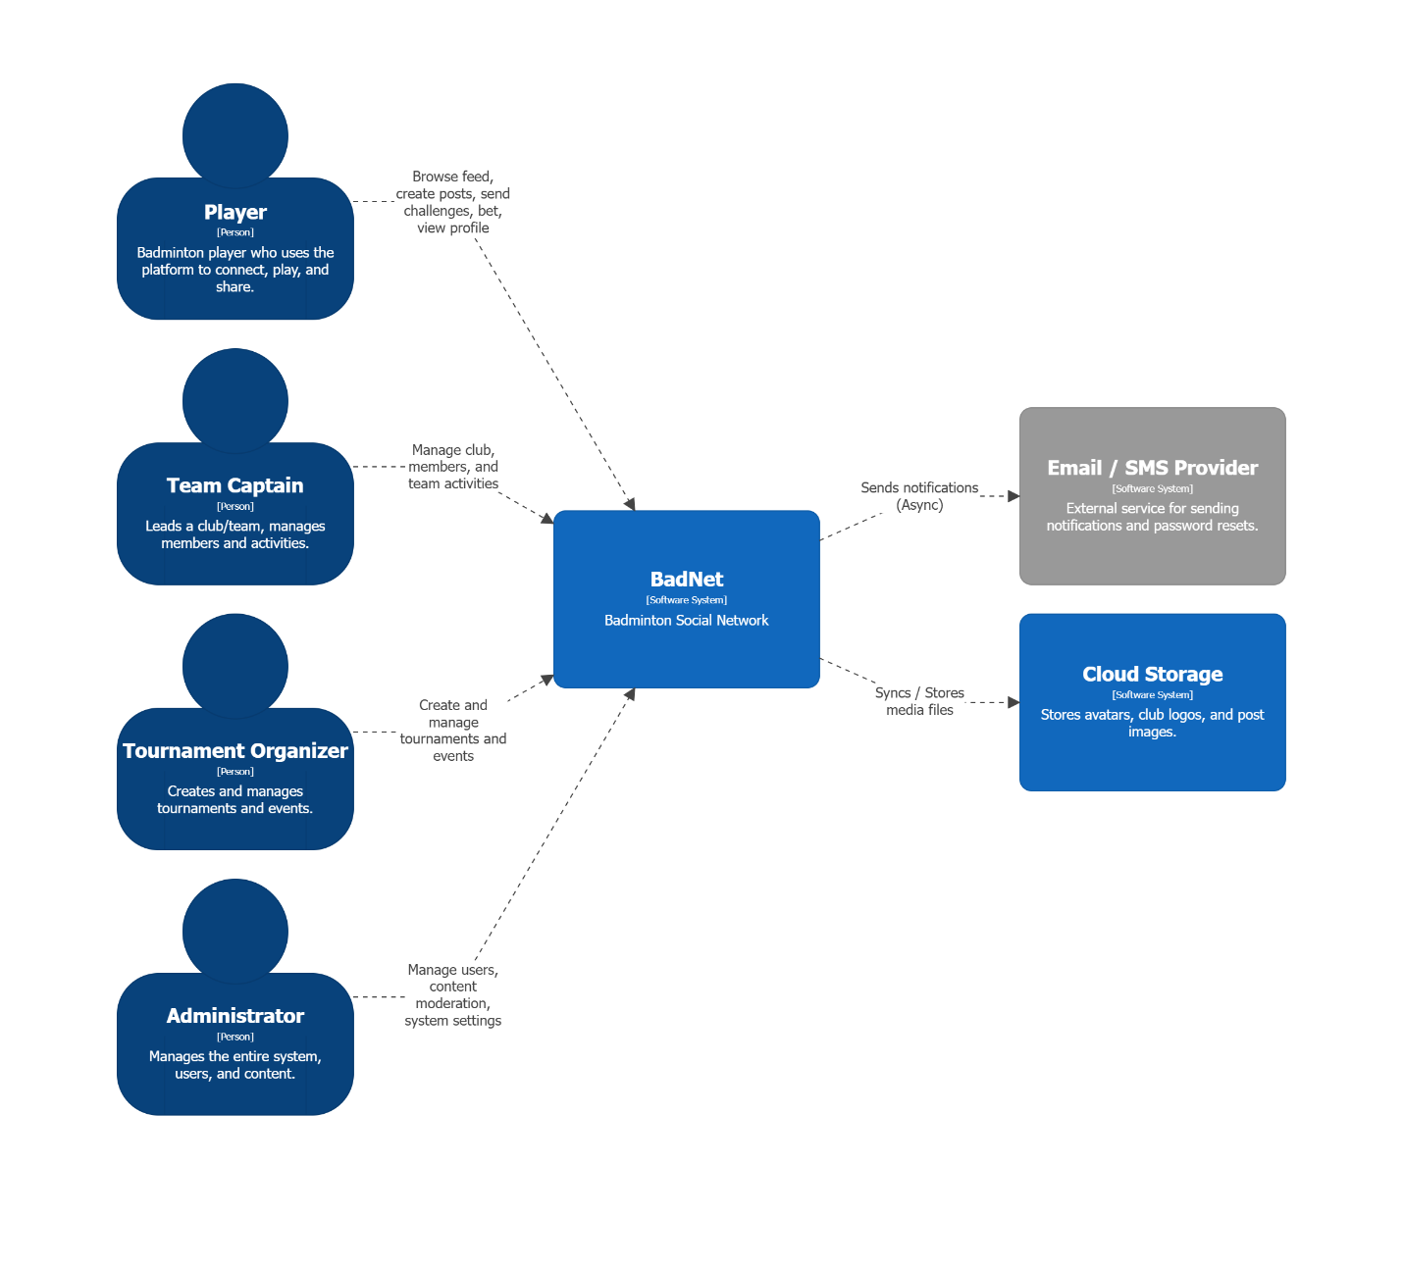
Figure 2. C4 Level 1 - System context diagram.
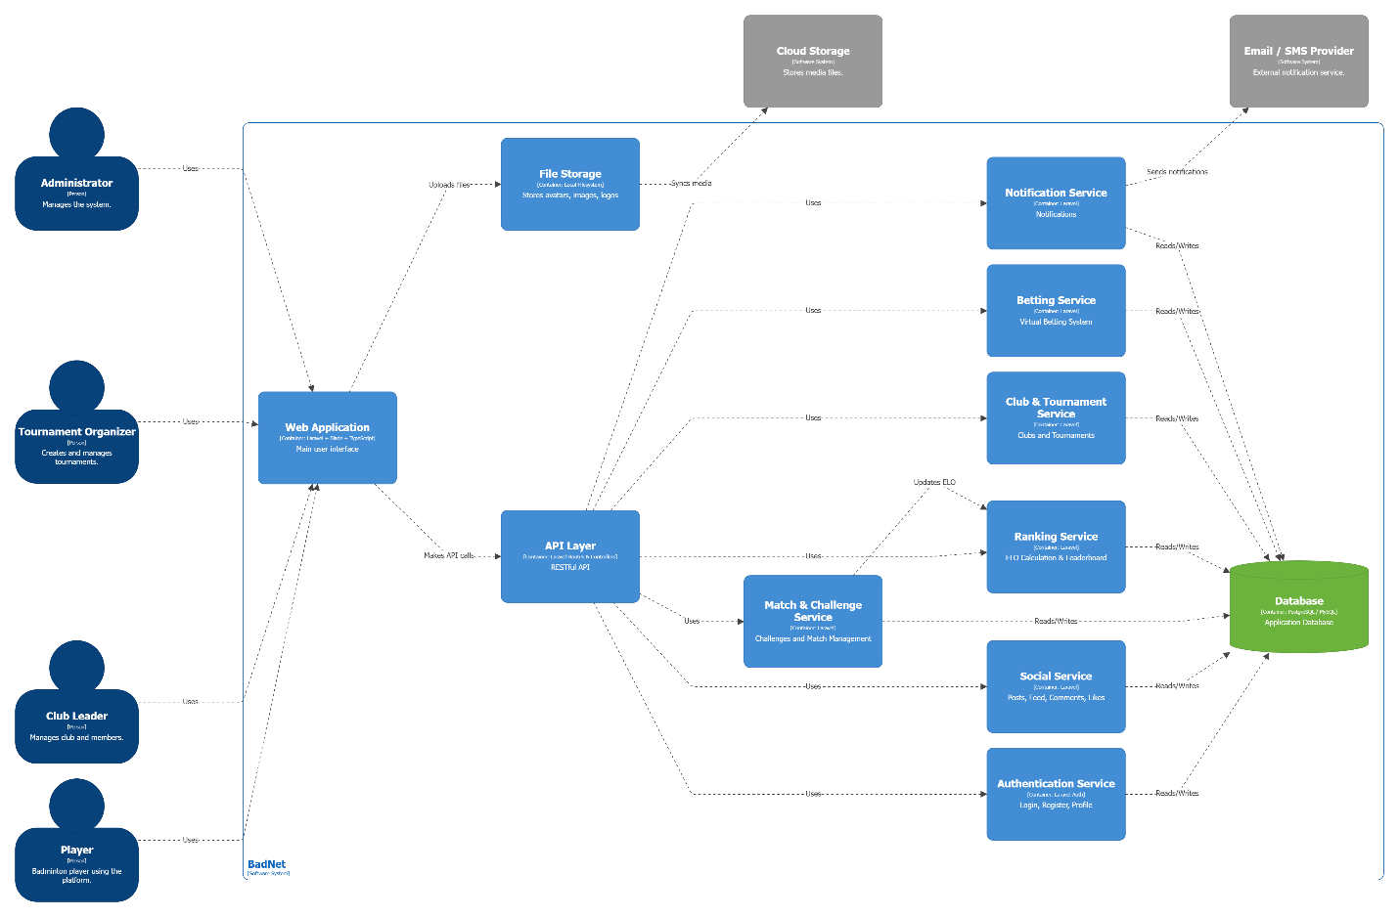
Figure 3. C4 Level 2 - Container diagram.
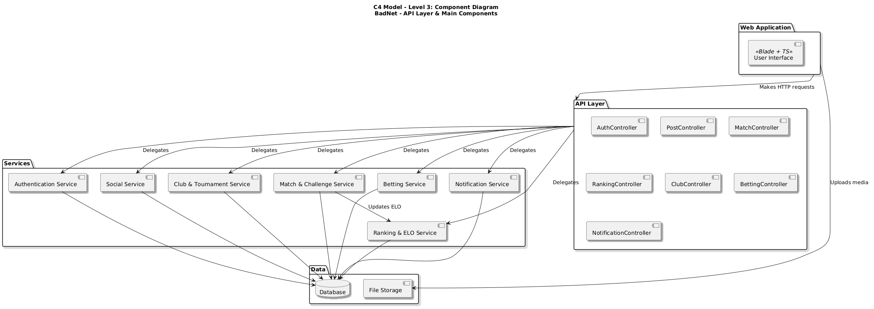
Figure 4. C4 Level 3 - Component diagram.
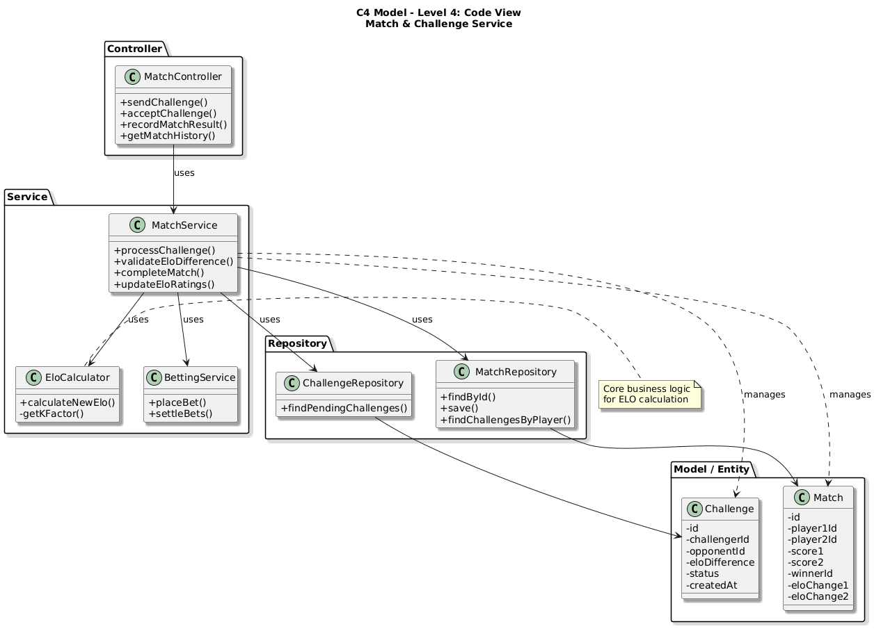
Figure 5. C4 Level 4 - Code diagram.

3.3 Database Design
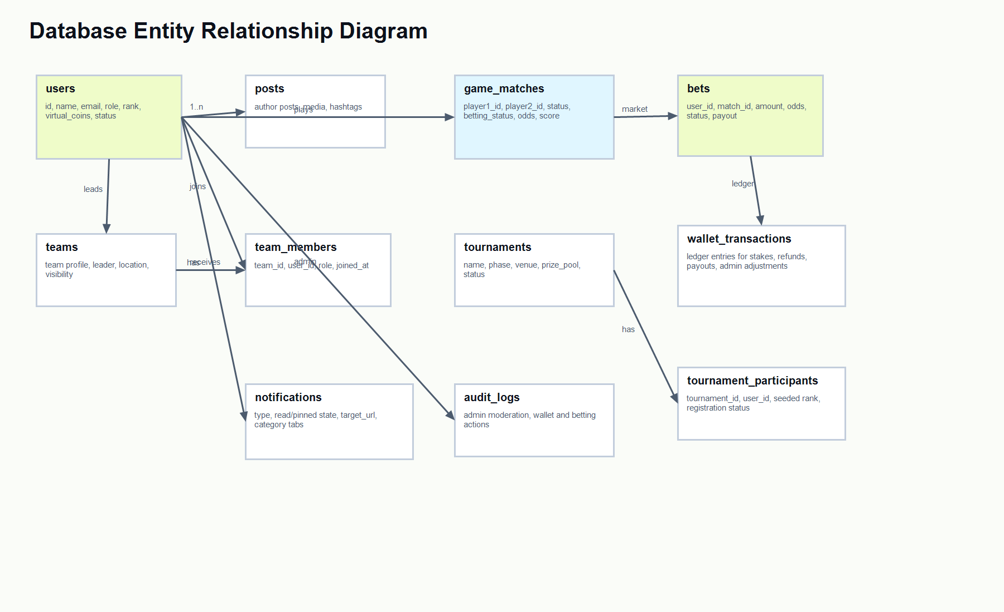
Figure 6. Database entity relationship diagram.
Entity | Responsibility
users | Stores identity, roles, rank, skill and virtual wallet balance.
game_matches | Stores match players, schedule, result, status and betting metadata.
bets | Stores individual predictions, stake, odds, status and payout state.
wallet_transactions | Append-only ledger for all wallet changes.
teams / team_members | Stores team ownership and membership.
tournaments / tournament_participants | Stores tournament registration and membership.
notifications | Stores social, system, match and betting notifications.

3.4 REST API and Route Design
Module | Representative Routes | Purpose
Authentication | GET /login, POST /login, GET /register, POST /register | Account access and email verification flow.
Matches | GET /matches, POST /matches, POST /matches/{match}/bet | Match discovery, creation, result and betting.
Teams | GET /teams, POST /teams/{team}/join, DELETE /teams/{team}/members/{user} | Team browsing and leader/admin membership control.
Tournaments | GET /tournaments, POST /tournaments/{tournament}/join | Tournament discovery and participant management.
Notifications | GET /notifications/recent, POST /notifications/mark-all-read, POST /notifications/{notification}/pin | Notification center actions.
Admin | GET /admin/players, POST /admin/players/{user}/wallet, POST /admin/betting/matches/{match}/odds | Operational control panel.

3.5 UML Diagrams
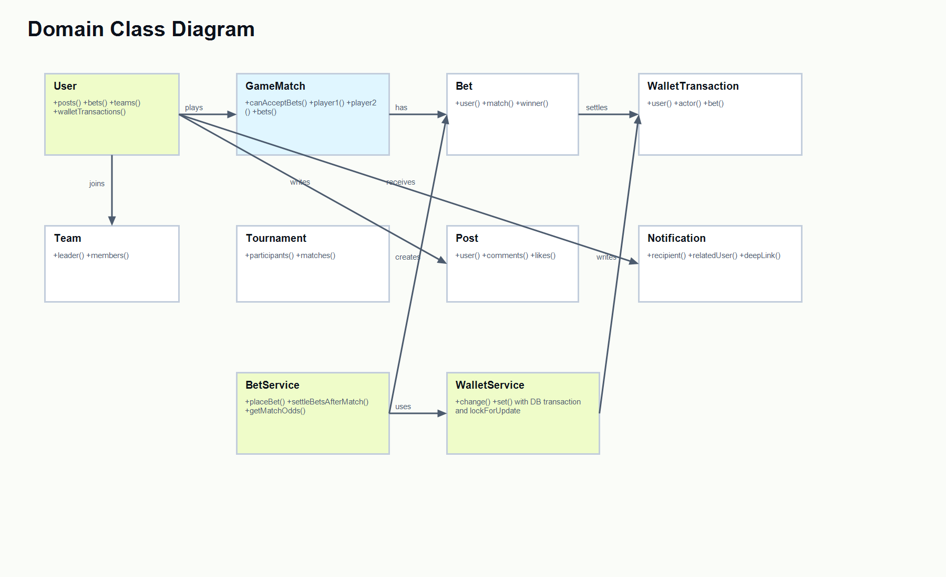
Figure 7. Domain class diagram.
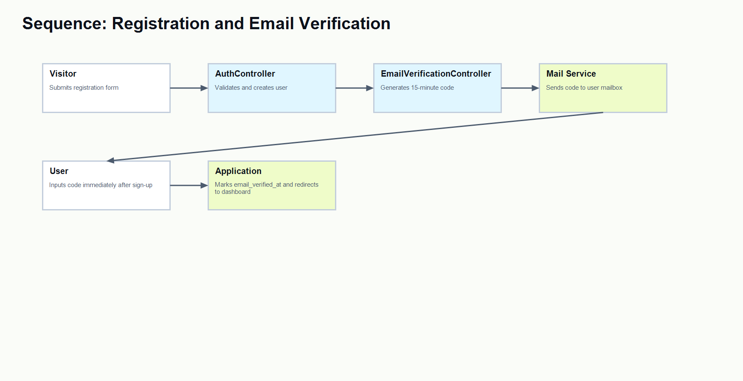
Figure 8. Sequence diagram - registration and email verification.
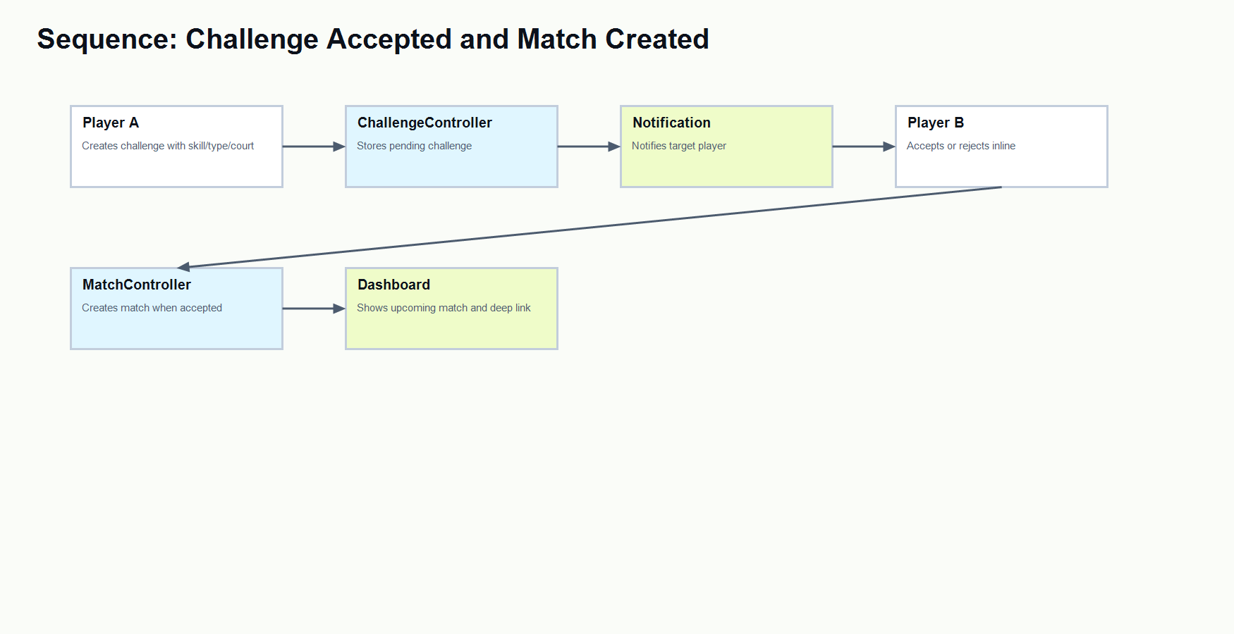
Figure 9. Sequence diagram - challenge accepted and match created.
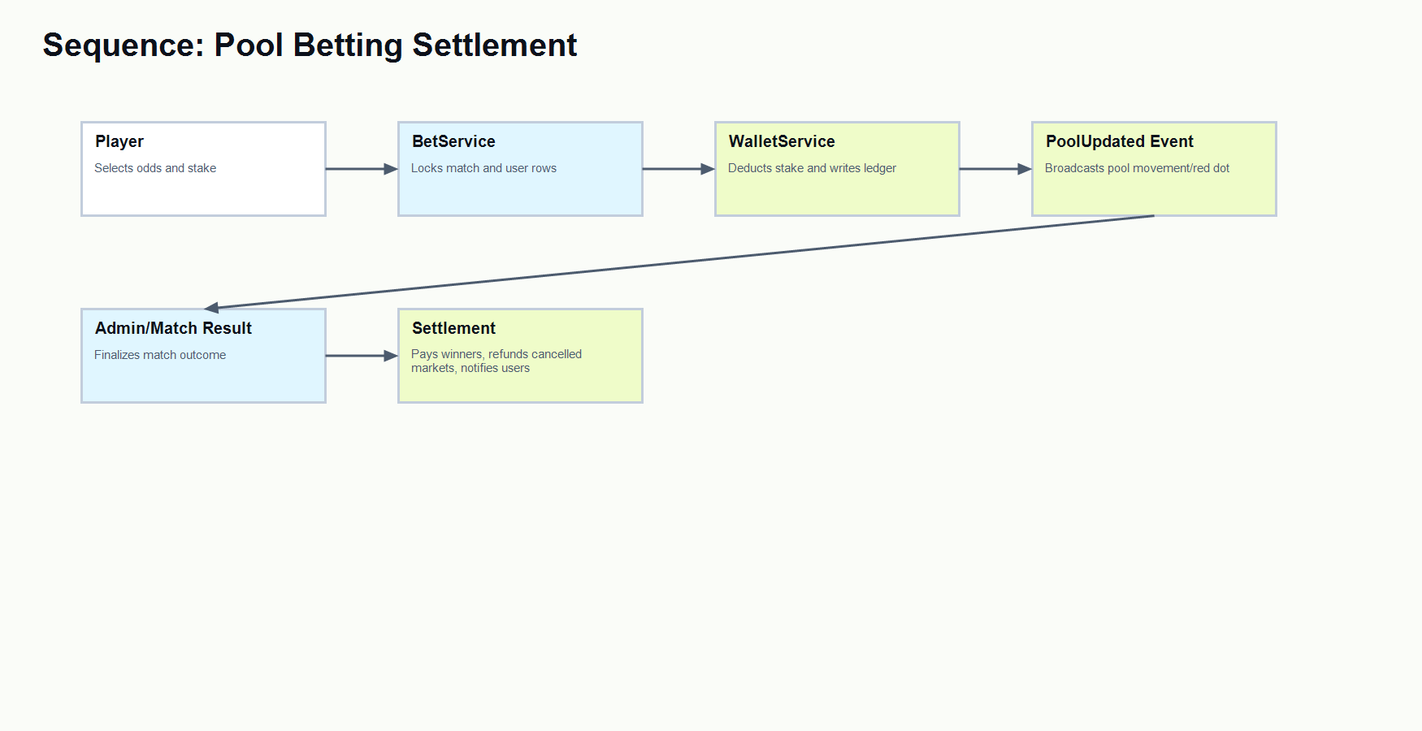
Figure 10. Sequence diagram - pool betting settlement.
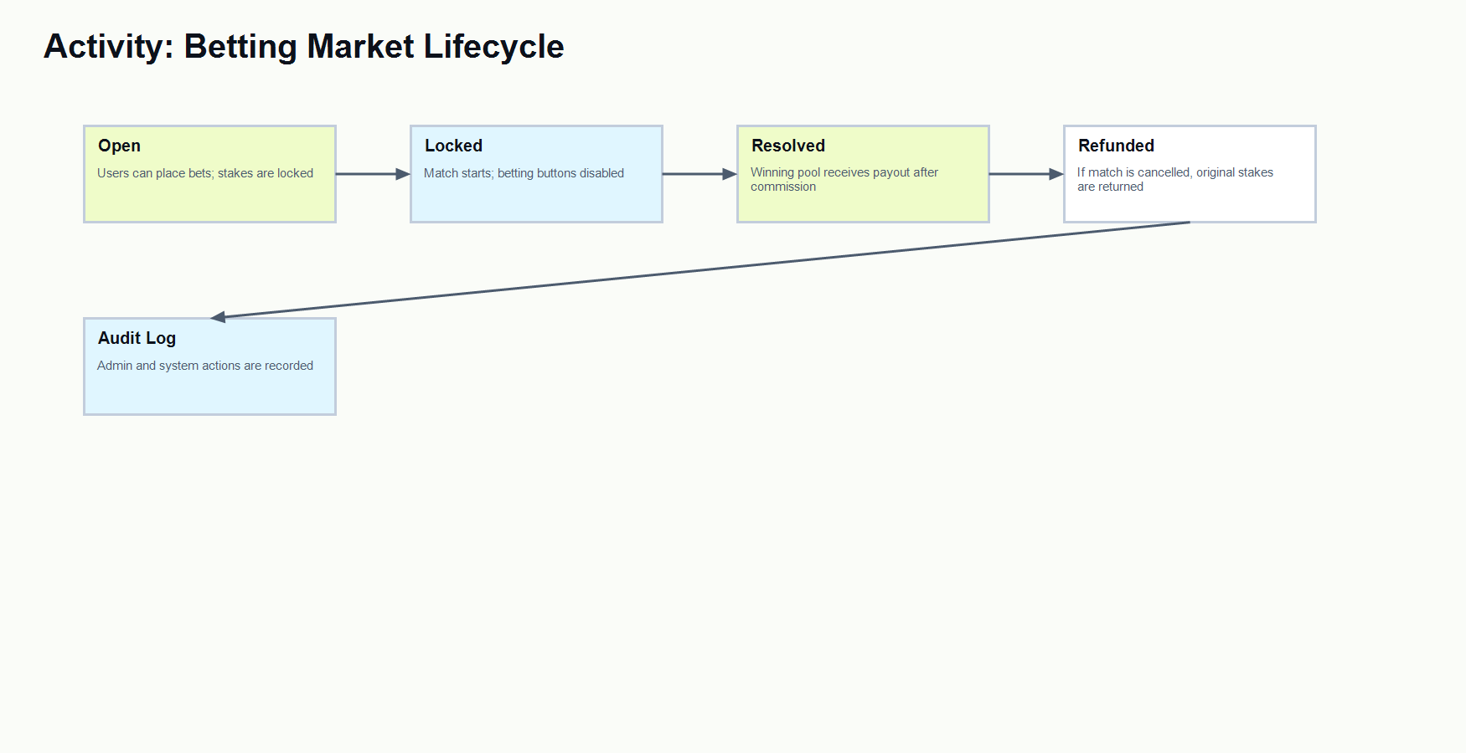
Figure 11. Activity diagram - betting market lifecycle.
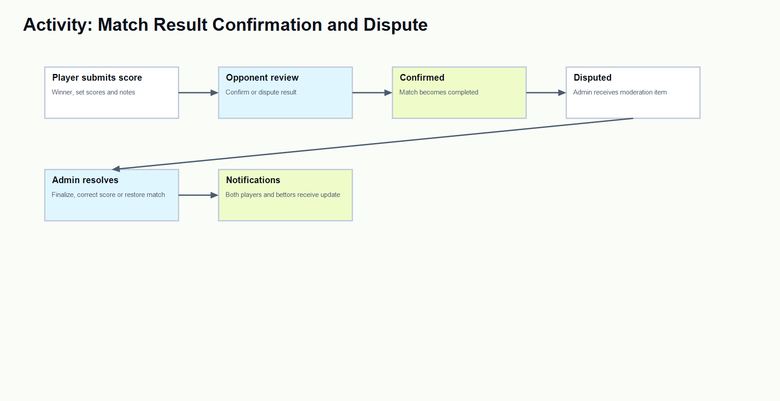
Figure 12. Activity diagram - match result confirmation and dispute.

3.6 Architecture Decision Records
ADR | Decision | Reason | Consequences
ADR-01 | Use Laravel MVC with Blade for core app. | The project needs fast CRUD, routing, auth and server-side forms. | Simple deployment and clear controller/service boundaries.
ADR-02 | Use service classes for betting and wallet logic. | Betting integrity is architecturally significant. | Rules are centralized and easier to test.
ADR-03 | Use pool betting instead of direct cash betting. | The academic demo must avoid real-money risk. | Virtual points can be locked, refunded and audited safely.
ADR-04 | Use CSS variables for theme and visual consistency. | Player and admin UI need shared tone and light/dark support. | Colors can be corrected globally without rewriting components.

3.7 UI Prototype and Screenshots
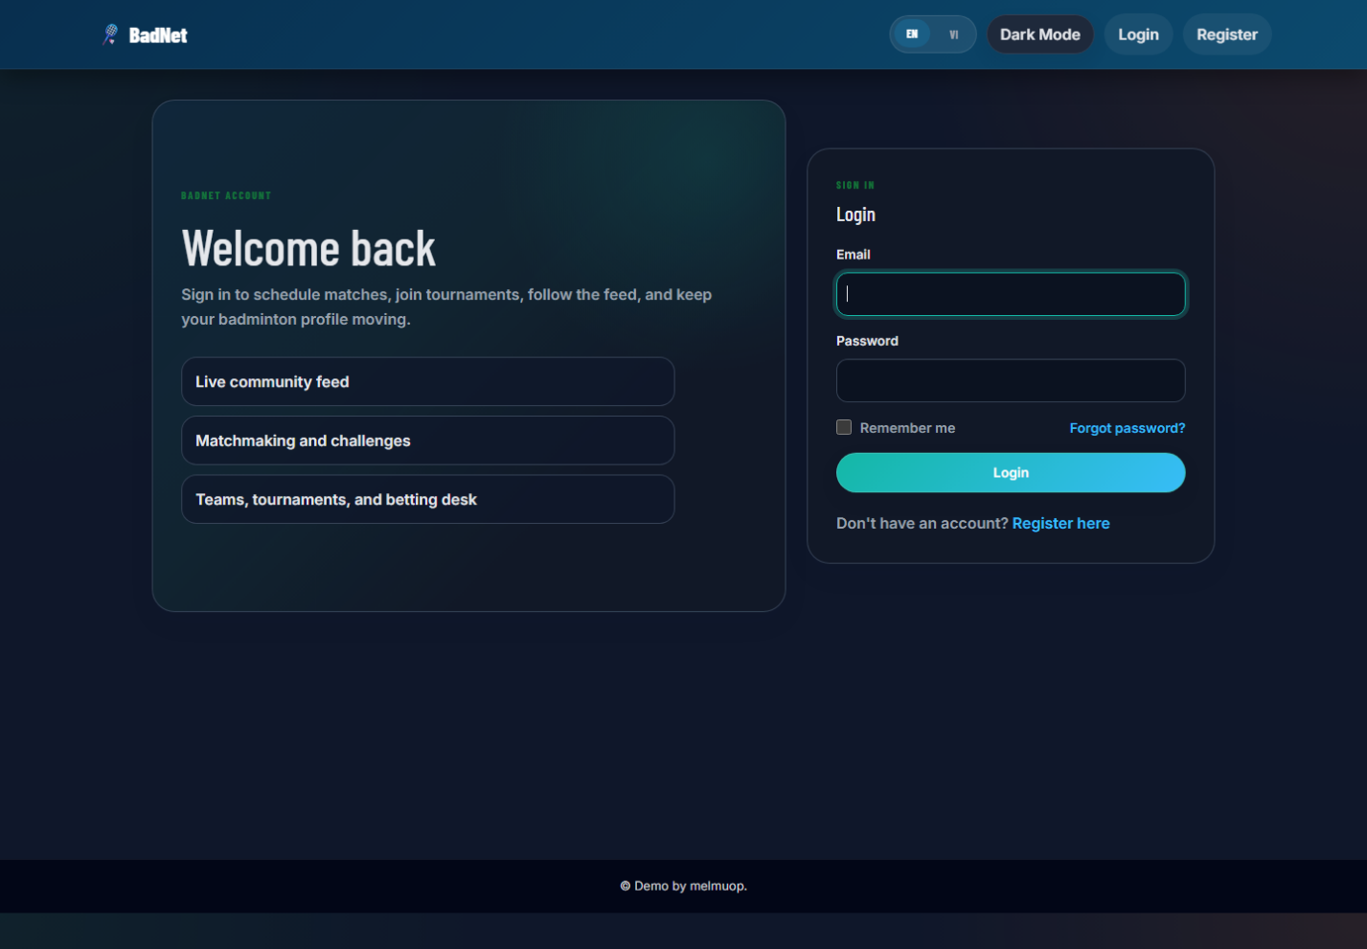
Figure 13. Login screen screenshot.
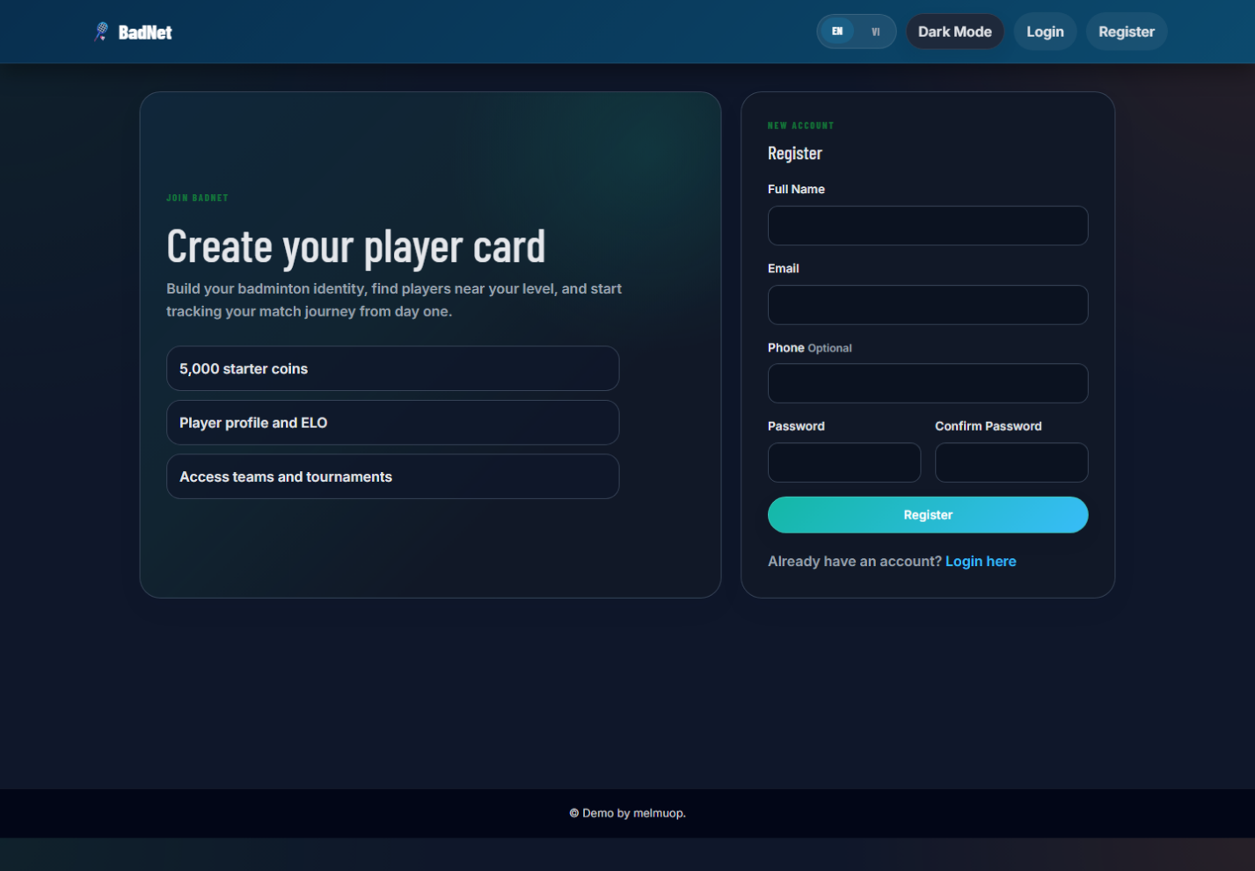
Figure 14. Registration screen screenshot.
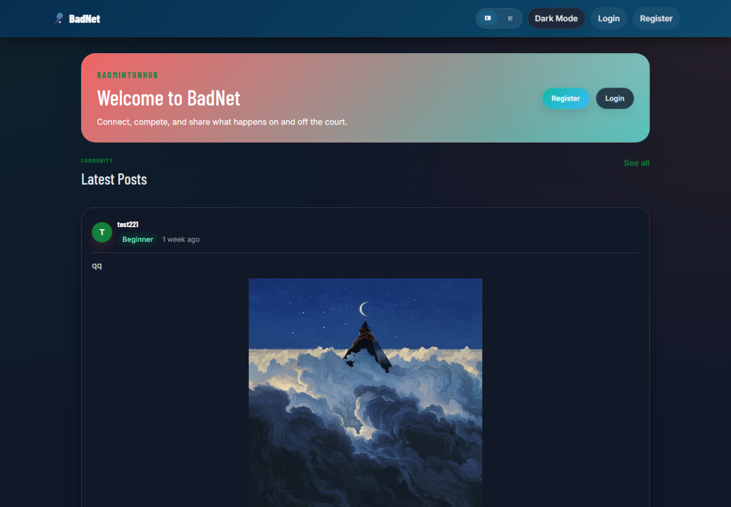
Figure 15. Public home screen screenshot.

Chapter 4: Implementation and Coding

4.1 Development Environment and Tools
The project is implemented with PHP 8.1.25, Laravel 9.52.21, Composer, Node/Vite for frontend assets, MySQL for storage, and PHPUnit/Laravel test runner for automated checks. The application is configured through src/.env and can be started with php artisan serve.

4.2 Project Directory Structure
src/
app/Http/Controllers/ Laravel controllers for user/admin workflows
app/Models/ Eloquent domain models
app/Services/ Betting, wallet and badminton helper services
resources/views/ Blade templates for player and admin UI
resources/react/ React player portal components
public/css/style.css Main CSS tokens and layout rules
routes/web.php Web route definitions
database/migrations/ Database schema evolution
tests/Feature/ Feature tests
Documents/
Design/ C4 and use case diagrams
Testing/ Test report evidence

4.3 Notable Implementation Techniques
Bet placement uses a transaction and row-level locks so concurrent users cannot overspend the same wallet balance.
DB::transaction(function () use ($user, $match, $amount) {
$match = GameMatch::whereKey($match->id)->lockForUpdate()->firstOrFail();
$user = User::whereKey($user->id)->lockForUpdate()->firstOrFail();
if ($user->virtual_coins < $amount) {
throw new InvalidArgumentException('Insufficient coins');
}
// create bet and lock stake through WalletService
});
Wallet changes are not stored only as a mutable balance. Every change creates a WalletTransaction record with before/after balances and optional actor, bet and metadata.
$lockedUser = User::withTrashed()->whereKey($user->id)->lockForUpdate()->firstOrFail();
$before = (int) $lockedUser->virtual_coins;
$after = $before + $amount;
$lockedUser->update(['virtual_coins' => $after]);
WalletTransaction::create([...]);
Admin operations are grouped under an authenticated admin route prefix. This keeps moderation, role assignment, wallet adjustment and betting actions behind the same access control boundary.

Chapter 5: System Testing

5.1 Test Plan
Testing covers authentication, social feed, notifications, challenges, matches, teams, tournaments, betting, wallet integrity and admin control. Automated tests are used for core integrity workflows, while manual UI test cases validate visual and business workflows that require browser interaction.

5.2 Test Cases
Test Case | Requirement | Scenario | Expected Result | Status
TC-001 | FR-01 | Register with valid email and password | Account is created and verification page is shown | Passed
TC-002 | FR-01 | Submit invalid verification code | System rejects code and keeps user unverified | Passed
TC-003 | FR-01 | Request password reset email | Email contains reset link and 15-minute warning | Passed
TC-004 | FR-02 | Create a feed post | Post appears in community feed | Passed
TC-005 | FR-02 | Like and unlike a post | Count and visual state update correctly | Passed
TC-006 | FR-02 | Comment on a post | Comment appears and notification is created | Passed
TC-007 | FR-03 | Create match using quick match form | Open match appears in match list | Passed
TC-008 | FR-03 | Accept a challenge invitation | Challenge becomes accepted and match is created | Passed
TC-009 | FR-03 | Reject a challenge invitation | Challenge becomes rejected and no match is created | Passed
TC-010 | FR-04 | Join a listed database team | User becomes visible in member list | Passed
TC-011 | FR-05 | Leader adds a team member | Member row is inserted | Passed
TC-012 | FR-05 | Leader removes a team member | Member row is removed and UI refreshes | Passed
TC-013 | FR-06 | Open tournament detail page | Detail page loads without 404 | Passed
TC-014 | FR-07 | Admin adds tournament participant | Participant appears in tournament list | Passed
TC-015 | FR-07 | Admin removes tournament participant | Participant is removed | Passed
TC-016 | FR-08 | Open bet slip from live match odds | Bet slip displays both players and odds | Passed
TC-017 | FR-08 | Enter stake greater than wallet | Confirm button is disabled with warning | Passed
TC-018 | FR-09 | Confirm valid bet | Wallet decreases and Bet row is pending | Passed
TC-019 | FR-09 | Cancel match with pending bets | Stake is refunded via wallet transaction | Passed
TC-020 | FR-10 | Admin updates odds | Odds are stored and shown in admin/user betting views | Passed
TC-021 | FR-10 | Admin deletes odds | Market stops displaying manual odds | Passed
TC-022 | FR-10 | Admin suspends betting market | Betting status changes and user betting closes | Passed
TC-023 | FR-11 | Admin bans user | User cannot continue normal account usage | Passed
TC-024 | FR-11 | Admin restores banned user | User can access normal routes again | Passed
TC-025 | FR-11 | Admin changes user role to admin | User receives admin access | Passed
TC-026 | FR-12 | Admin sets wallet balance | Balance changes and ledger entry is created | Passed
TC-027 | FR-12 | Admin adds wallet adjustment reason | Reason is stored in transaction description | Passed
TC-028 | FR-13 | Mark all notifications as read | Unread red dot disappears | Passed
TC-029 | FR-13 | Pin and unpin notification | Pinned item stays at top until unpinned | Passed
TC-030 | FR-14 | Hover chart area | Tooltip follows pointer and shows nearest value | Passed
TC-031 | FR-15 | Switch to dark mode | Cards, text and forms remain readable | Passed
TC-032 | FR-15 | Switch to light mode | Admin tables and inputs use light-mode colors | Passed

5.3 Test Results Summary
Metric | Value
Total documented test cases | 32
Passed | 32
Failed | 0
Blocked | 0
Automated evidence | PHPUnit feature tests for betting integrity and locale switching passed during project verification.
Manual evidence | UI workflows documented in Documents/Testing/BadNet_Test_Report.docx.

5.4 Quality Attribute Testing
Attribute | Scenario | Result
Integrity | Multiple betting operations update wallet through locked transactions. | No negative wallet balance allowed.
Security | Guest opens /admin/players. | Request is blocked by auth/admin middleware.
Usability | User opens notification center with many categories. | Tabs separate interaction, match, betting/wallet and system notifications.
Maintainability | Admin wallet adjustment added after initial design. | Change localized to admin players controller/view and WalletService.

Chapter 6: Deployment and User Guide

6.1 System Requirements
Required software: PHP 8.1 or newer, Composer, Node.js 18+, npm, MySQL 8 or compatible MariaDB, and a modern browser. Recommended local environment: Windows PowerShell, XAMPP or standalone MySQL, and Laravel development server.

6.2 Installation and Run Instructions
cd src
composer install
npm install
copy .env.example .env
php artisan key:generate
php artisan migrate --seed
npm run build
php artisan serve

6.3 Demo Accounts
Role | Email | Password | Purpose
Admin | admin@example.com | password | Admin panel, betting control, role and wallet management.
Player | testuser@example.com | password | Player portal, teams, matches, notifications and betting.
Player | hunter_rain@hotmail.com | configured locally | Development account used during implementation.

6.4 User Guide for Main Features
Players use the dashboard to view community activity, notifications and quick match actions. The Challenges page supports quick opponent discovery through skill and match-type controls. The Matches and Betting sections provide live/upcoming markets, bet slips, pool movement and wallet warnings. Teams and Tournaments show membership/registration workflows. Admins use the left sidebar to manage players, betting markets, tournaments, schedules, content moderation, statistics and audit logs.

Chapter 7: Conclusions and Future Work

7.1 Achievements
The project delivers an integrated badminton social network with player interactions, match finding, team and tournament management, virtual pool betting, wallet ledger, notification center and admin operations panel. The implementation applies architectural separation through MVC, services, models, middleware and reusable CSS tokens.

7.2 Limitations and Challenges
The system is designed as an academic demo and does not include real payment processing, official tournament data feeds, mobile-native push notification packaging or large-scale production monitoring. Some real-time features are architected through events and notification endpoints, but a production deployment would require a dedicated WebSocket server and queue worker.

7.3 Future Work
Future improvements include production WebSocket deployment, fraud/risk scoring for suspicious betting behavior, richer tournament bracket generation, court provider integration, push notification opt-in, moderation analytics, exportable financial reports and mobile-friendly PWA installation.

References
[1] L. Bass, P. Clements, and R. Kazman, Software Architecture in Practice, 4th ed. Addison-Wesley, 2021.
[2] S. Brown, "The C4 model for visualising software architecture," c4model.com, accessed Jun. 16, 2026.
[3] R. T. Fielding, "Architectural Styles and the Design of Network-based Software Architectures," Doctoral dissertation, University of California, Irvine, 2000.
[4] Laravel, "Laravel Documentation," laravel.com/docs, accessed Jun. 16, 2026.
[5] PHP Group, "PHP Manual," php.net/manual, accessed Jun. 16, 2026.
[6] Oracle, "MySQL 8.0 Reference Manual," dev.mysql.com/doc, accessed Jun. 16, 2026.
[7] OWASP Foundation, "OWASP Top Ten," owasp.org, accessed Jun. 16, 2026.
[8] React Team, "React Documentation," react.dev, accessed Jun. 16, 2026.
[9] Vite Team, "Vite Guide," vite.dev/guide, accessed Jun. 16, 2026.
[10] Chart.js Contributors, "Chart.js Documentation," chartjs.org/docs, accessed Jun. 16, 2026.
[11] Microsoft, "Threat Modeling Tool and Security Development Lifecycle Guidance," microsoft.com/security, accessed Jun. 16, 2026.
[12] Martin Fowler, "Patterns of Enterprise Application Architecture," Addison-Wesley, 2002.

